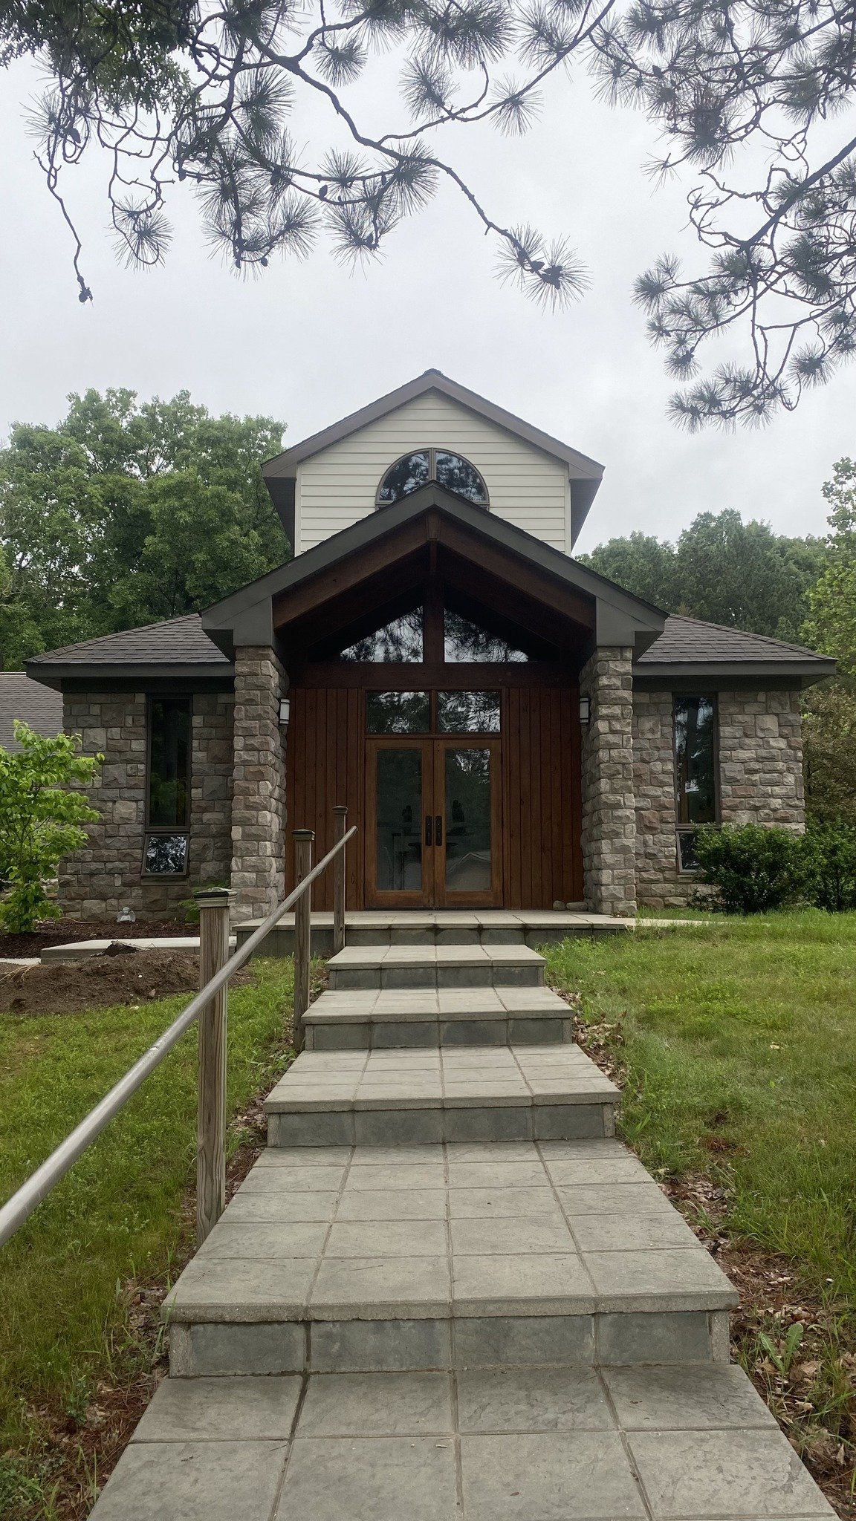
“Come Away for a While”
Evening of April 28th – May 1st
At St. Augustine House in Oxford, MI.
https://staugustines.house/visitors/

A time for personal reflection, rest and for a special time to go apart and listen, to draw close to the Presence and be refreshed in your inner spirit.

Arrive Sunday from 3pm-6pm join in Vespers then supper followed by a short meeting before you enter your retreat and leaving Wednesday after Sext at noon.

Each day you will have the opportunity to sit with a trained spiritual guide that can help you move closer to the Lord. Or perhaps read, walk along the wooded roadside, or the paths through the property, sit in on a session of teaching about faith practices or engage in a time of work, there are often simple tasks or chores with which guests can help. You will also be able to join the residents and engage in the hours of prayer throughout the day.

Each day you will be provided with two meals: dinner at 12:30 and supper after Vespers. Breakfast is eaten in silence on a self-serve basis. Bread, cereal, coffee, tea, milk, and juice will be available in the dining area after Lauds until 7:15 a.m. You will have a private room with your own bathroom.

Register Here

Pay Here
Retreat leader Rev. Ken Greble with questions. (616)460-1122
pastorken@gracelutheranhowell.org

Cost is $240. per person.

